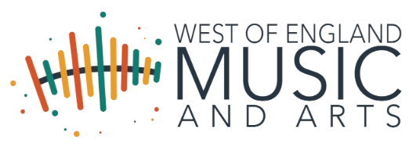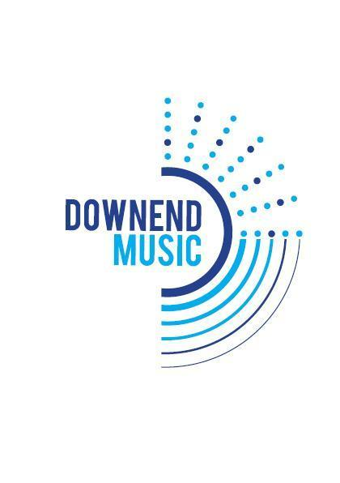

June, 26

Dear Parent(s)/Carer(s),

WEMA (West of England Music Alliance) is Downend School’s preferred provider of additional music teaching. Last year the WEMA provided tuition to over 4000 young musicians in South Gloucestershire in either full class, small group or individual lessons. Here at Downend School, over 100 students receive tuition from highly qualified teachers provided by the Hub.

Downend School wholeheartedly supports any child who wishes to learn a musical instrument, firmly believing that this will help to develop their general listening skills, co-ordination, fine motor skills, self-confidence, self-expression, personal responsibility and social interaction as well as their general enjoyment of music. If you wish your child to have lessons but have issues regarding cost please do contact Downend School finance office.
WEMA is able to provide tuition on all orchestral and rock and pop instruments, voice and keyboard:
Woodwind | Flute / Recorder | Oboe | Clarinet | Bassoon | Saxophone
Brass | Trumpet/Cornet | French / Tenor Horn | Trombone | Baritone/Euphonium | Tuba
Strings | Violin | Viola | Cello | Double Bass
Other | Acoustic Guitar (Classical) | Electric/Bass Guitar | Drum Kit | Voice | Electronic Keyboard and Piano

Instrumental Lessons: The Key Facts

- Lessons: There will be 30 lessons per academic year, usually 10 lessons per double term. The lessons will last 20 or 30 minutes.
- Group Size: There are 3 different lesson sizes: individual, a pair or in a group (up to four) students. Paired and group lessons can take place assuming that there are enough students wishing to learn the same instrument who are at the same level of musical experience.
- Invoices: Invoices will be issued directly by WEMA.
- Timetabling: Times will be emailed to parents by the instrumental teachers as well as posted on the music notice board in school. They are subject to change and it is the students’ responsibility to check these times on the morning of their lesson and to politely excuse themselves from school lessons to attend.
- Terms and Conditions: For WEMA tuition these can be seen at https://wema.org.uk/guides-policies-and-tcs/tuition-terms-and-conditions/

You can also take advantage of the Assisted Instrument Purchase Scheme which allows you to purchase an instrument through school which means you do not have to pay VAT. Instruments bought through this scheme must be used for regular lessons in school.

Charges for the 2026/2027 Academic year will be
 | 30 minutes individual | 20 minutes individual | 30 minutes Paired lesson | Group Lesson
From September 2026 | £253 for 10 lessons | £169 for 10 lessons | £124 for 10 lessons | £85 for 10 lessons

What to do now to register for lessons:

- Register your interest online at Registration - West of England Music and Arts as soon as possible and ideally by 31st August, 2026. If the deadline has passed, please still register using this link and we will do our best to organise lessons to start as soon as possible. You can use this link at any time in the academic year.
- You will be sent an invoice that must be paid before lessons can commence.

- If there is no current availability for your chosen instrument, you will be placed on a waiting list and we will work hard to find you a place as soon as we can.

- Confirmation of instrumental lessons will be given as soon as the Music Hub has arranged the timetables. A copy will still be emailed to you and displayed in the school.

If you have any queries regarding registration, payments or instrument hire, please do not hesitate to contact the music hub admin team at sian.noctor@wema.org.uk or call 01454 863147.

Please feel free to contact me directly at alice.muir@cset.co.uk if you want to discuss anything at all regarding instrumental lessons at Downend School.

Kind regards,

Alice Muir
Head of Music

